实验4编写java测试脚本程序基础实验

|  |  |  |  |  |  |  |  |
| --- | --- | --- | --- | --- | --- | --- | --- |
| 组 别 |  | 实验人员 | KAFLE SAMRAT | | | | |
| 实验项目名称 | 编写java测试脚本程序基础实验 | | | | | | |
| 实 验 类 别 | 验证型□ 设计型□ 综合型□ | | | | | | |
| 实 验 工 具 | Firefox浏览器、eclipse | | | 实验地点 | J13-132 | 实验日期 | 2020.12.14 |
| 学生实验小结 | 编写eclipse程序时发现找不到登录按钮的classname，本来以为连带空格的也是按钮的classname,后来才知道空格用来分隔子类和属性，选中classname后测试代码运行成功 | | | | | | |
| 教师评语 | 指导教师签名：  年 月 日 | | | | | | |
| 实验成绩 |  | | | | | | |

1实验内容和目标

1.1实验内容

本次实验通过使用Eclipse、Selenium WebDriver jar包以及Gecko驱动程序，学习使用java语言编写简单的Selenium测试脚本的基本流程，并能够自行编写简单的登录测试脚本。

1.2实验目标

（1）安装配置Selenium WebDriver；

（2）编写一个简单的java测试脚本程序。

2实验方案设计

2.1实验环境

Eclipse、firefox浏览器、selenium

Log in to the CSDN website script::

import org.openqa.selenium.By;

import org.openqa.selenium.WebDriver;

import org.openqa.selenium.firefox.FirefoxDriver;

public class test2 {

public static void main(String[] args) {

System.setProperty("webdriver.gecko.driver", "C:\\Users\\zz\\Desktop\\Selenium实验指导书\\geckodriver-v0.23.0-win64\\geckodriver.exe");

System.setProperty("webdriver.firefox.bin", "C:\\Program Files\\Mozilla Firefox\\firefox.exe");

WebDriver driver = (WebDriver) new FirefoxDriver();

driver.get("https://passport.csdn.net/passport_fe/login.html");

String titile = driver.getTitle();

System.out.println("title is => " + titile);

driver.findElement(By.linkText("账号密码登录")).click();

// driver.findElement(By.className("btn btn-primary__disabled")).click();

driver.findElement(By.id("all")).sendKeys("151267499");

driver.findElement(By.id("password-number")).sendKeys("*******");

driver.findElement(By.className("btn-primary")).click();

try {

Thread.sleep(3000);

} catch (InterruptedException e) {

e.printStackTrace();

}

driver.quit();

}

}

实验步骤和结果:

Download the Selenium WebDriver Java client

Open the web site: <https://docs.seleniumhq.org/download/>

it will be redirected to the Selenium's official website "Download page, scroll down the page, click the Selenium Client & WebDriver Language Bindings Java a line under the" Download ", as shown in the figure below.

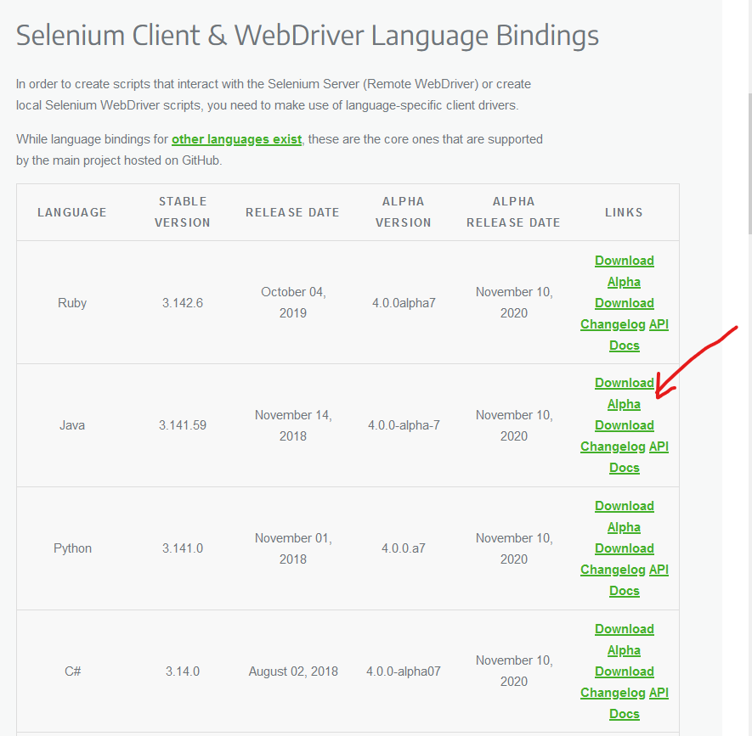

The downloaded file will be in a compressed format and the content will be extracted. It contains the basic JAR files needed to configure Selenium WebDriver in the Eclipse IDE.

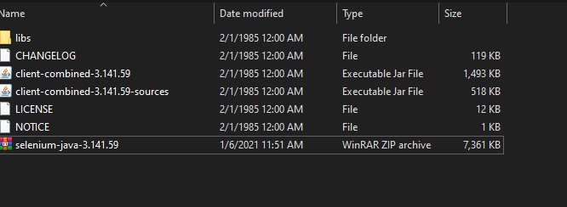

Configure the Selenium WebDriver

Launch Eclipse and create a new Java Project with whatever name you want, then right-click on the project and select Properties:

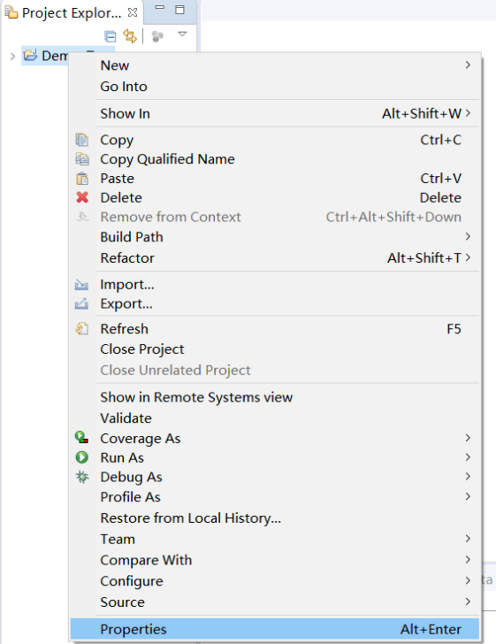

Click the "Java Build Path" option in the left pane, switch to the Libraries TAB, and then click the "Add External Jars" button:

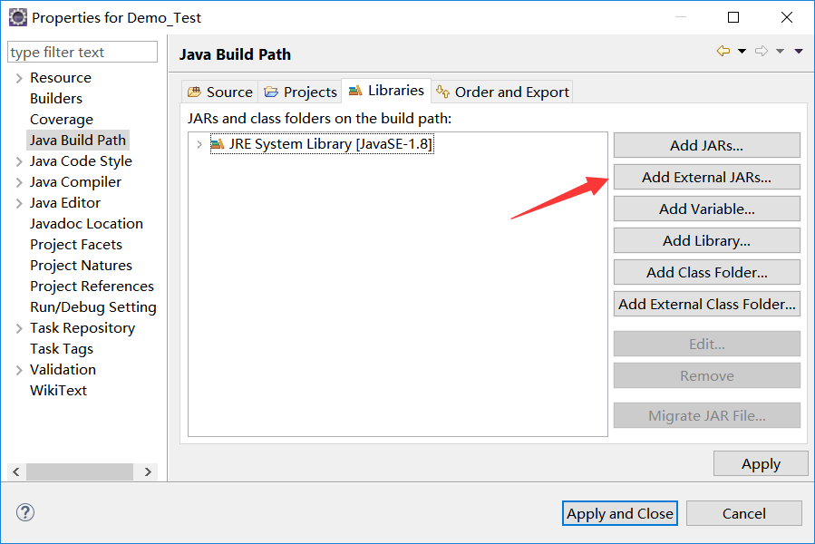

Find the unzippy directory of selenium-java-3.14 .zip and select the file shown in the figure to add:

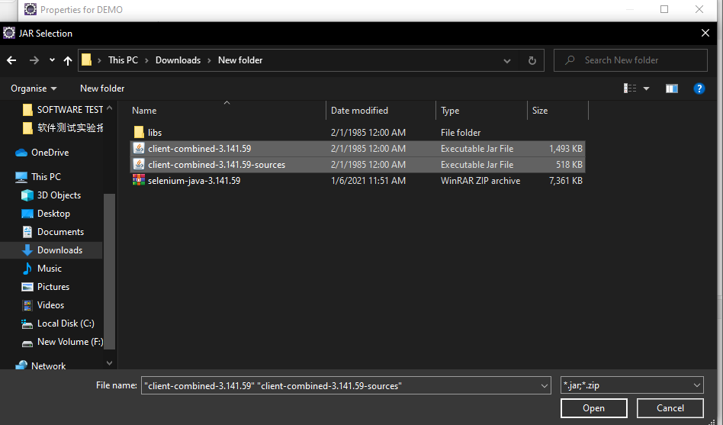

Repeat the same steps for the JAR in the "libs" folder.

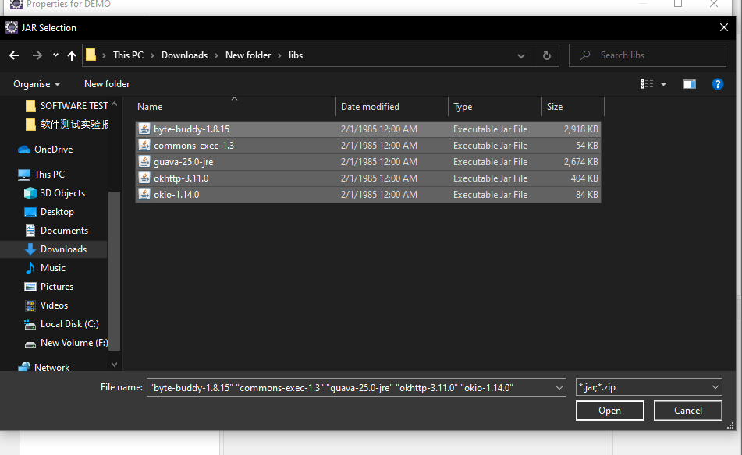

After adding, click Apply and Close buttons:

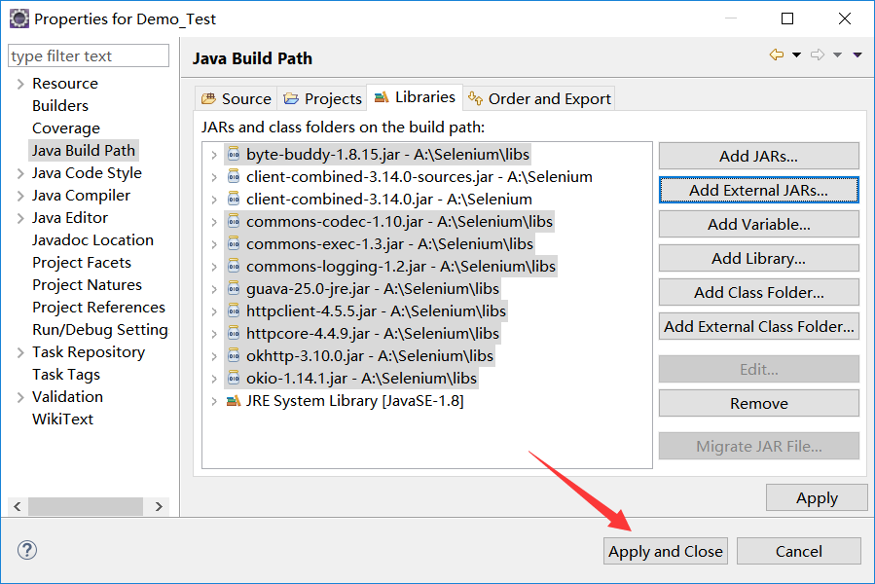

Familiar with the process of writing Java test scripts

To invoke the Firefox browser, download the Gecko driver and set the system properties for the Gecko driver. Open <https://github.com/mozilla/geckodriver/releases>

find corresponding to download:

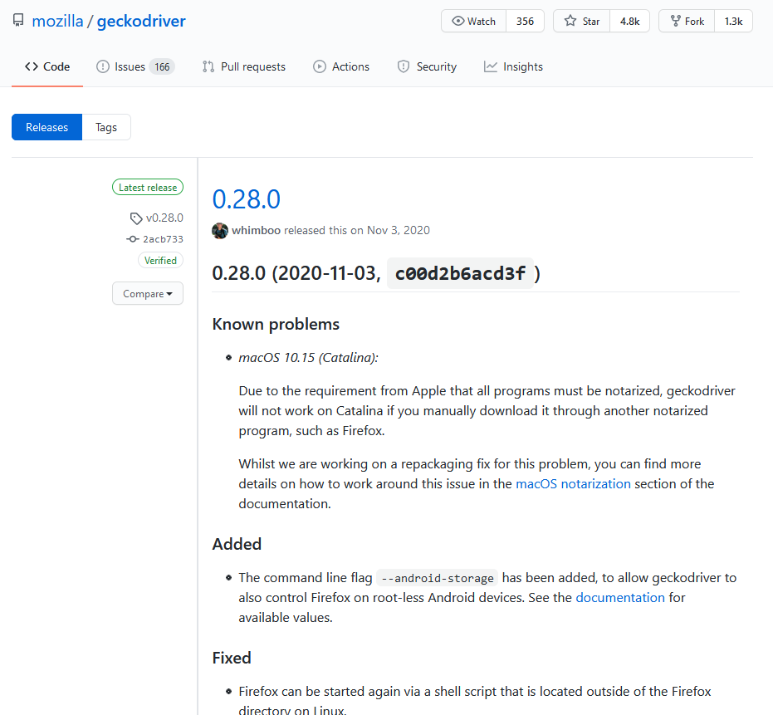

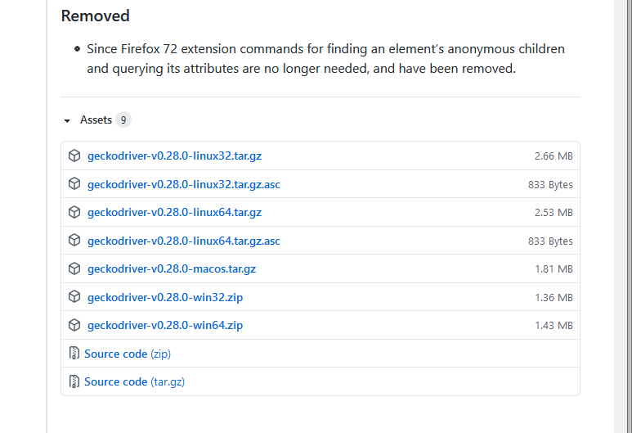

When the download is complete, unzip it to geckodriver.exe.

Create a new class and first set the necessary properties

The objects and variables are then instantiated

Launch your browser and open your website

By looking at the element, we know that the ID of the Baidu search box is "KW" :

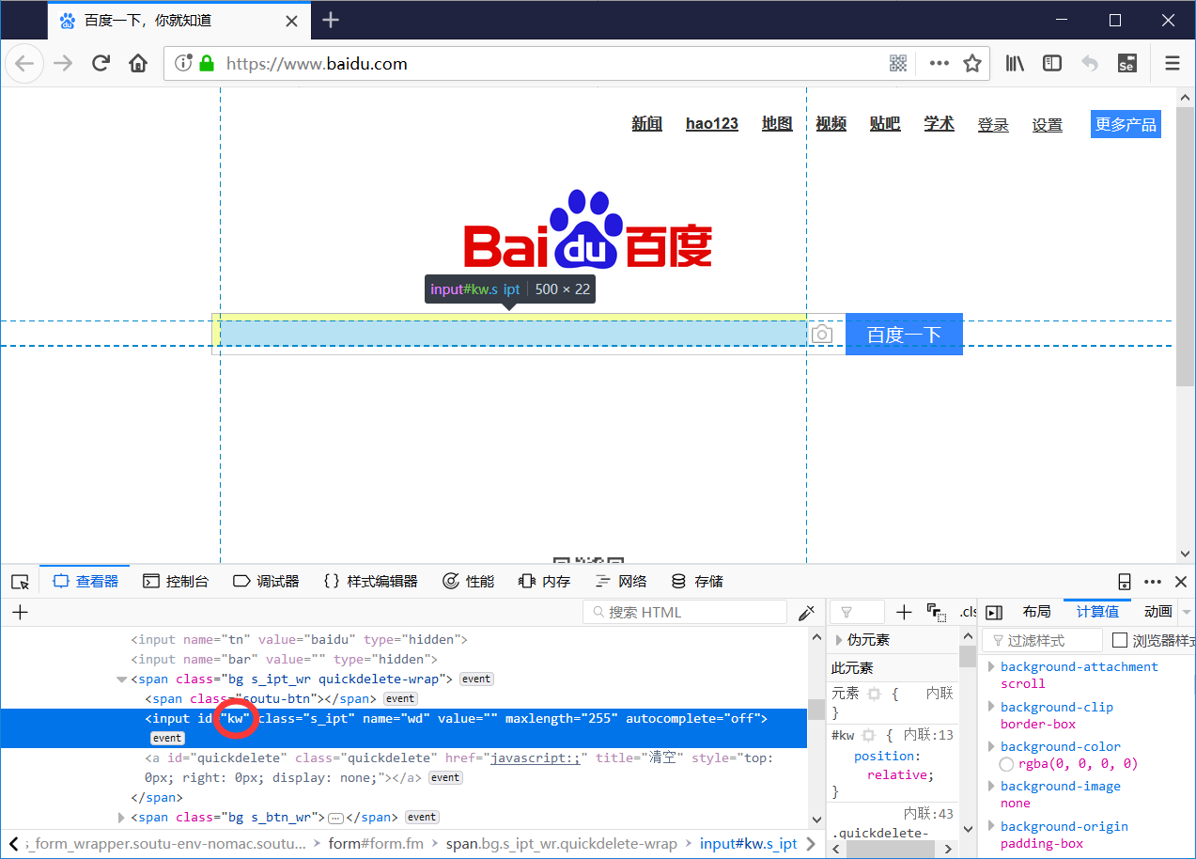

Use the same method to find out that the "Baidu" button ID is "su" :

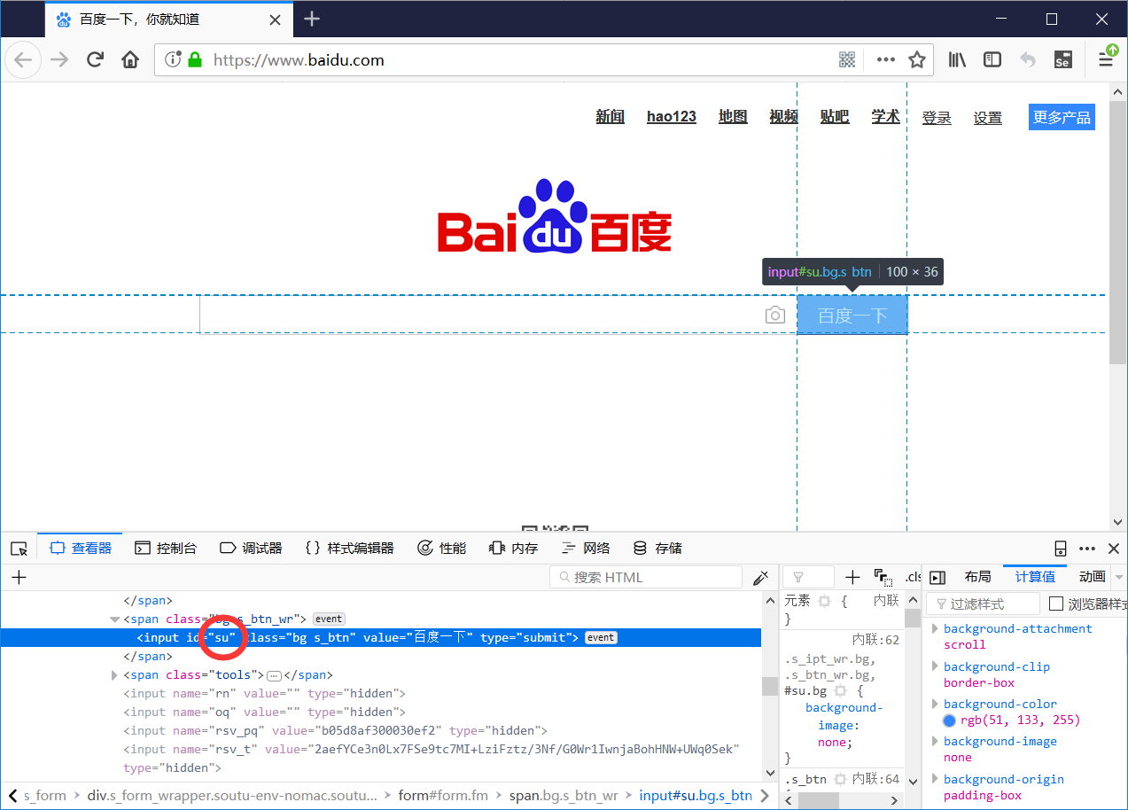

Here's how we mimic a normal user's search:

Enter Selenium in the input box

Click the "baidu" button

The browser closes with a 3-second delay

This completes the writing of a simple test case that opens a browser and searches for relevant content.

Write a login test script

Write a login test script for the site and run it according to the process of writing a Java test script in Task 3:

<https://passport.csdn.net/passport_fe/login.html>

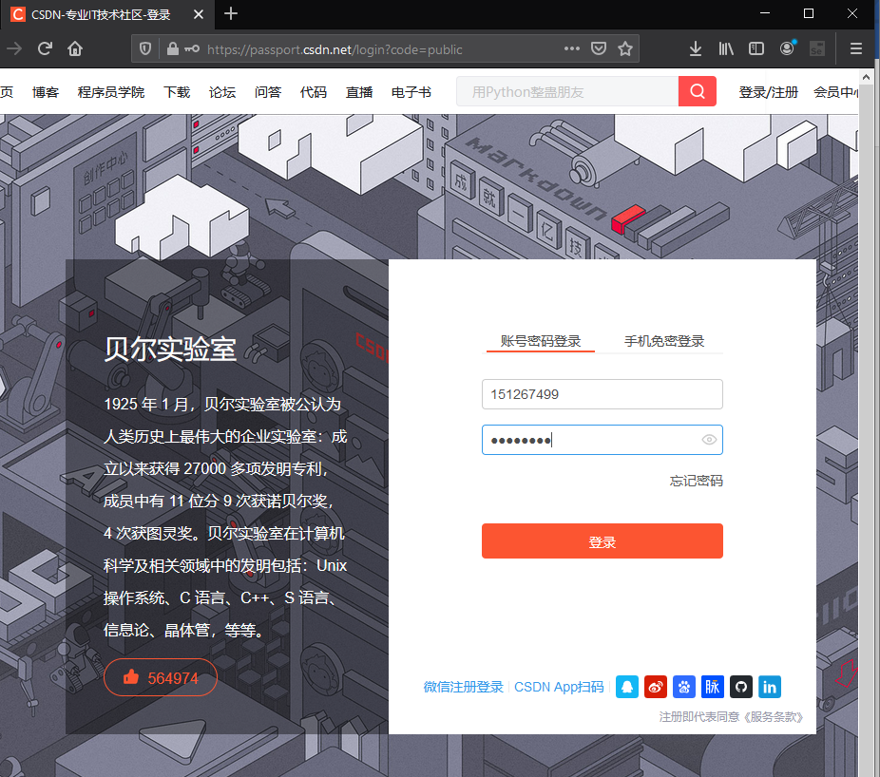

实验结果分析

Firefox浏览器出现登录界面并且自动输入账户密码，执行登录，说明Eclipse编写的测试代码运行全部成功。